Mini Project Proposal Report on

**“EVEREST DEAL”**

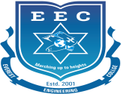

***Submitted to***

**Department of Computer and IT Engineering**

**Everest Engineering College**

**Sanepa-2, Lalitpur**

*in partial fulfillment for the award of the degree*

*of*

**BACHELOR OF COMPUER/IT ENGINEERING**

***Submitted By***

ABHISHEK SAH [21075393]

ABHISHEK SHRESTHA [21075394]

DIBAS TIMILSENA [21075410]

SHIRISH TRIPATHI [21075435]

Date Submitted: **01/03/2024**